American Heartland Rail: A Phased, Economically Viable Intercity Rail Network for the U.S. Midwest and South (Revised)
Slade Gilmer
Graduate Student, University of Alabama in Huntsville

Abstract
The American Heartland Rail (AHR) system is a proposed intercity passenger rail network connecting the Midwest and Southern United States through a phased, corridor-based approach. A simulation-based network model incorporating generalized cost, mode competition, and frequency-dependent demand was developed and calibrated using Amtrak FY2025 data.
Monte Carlo simulation results indicate that the finalized system achieves mean annual ridership of approximately 9 million passengers, farebox recovery ratios exceeding 1.3, and benefit-cost ratios (BCR) above 2.4. The system demonstrates strong robustness, maintaining farebox recovery above 1.0 in over 90% of simulations and requiring minimal operating subsidy in the vast majority of cases.
Results show that economically viable intercity rail in the United States can be achieved through network topology and mid-distance corridor chaining, where interconnected metropolitan regions generate strong network effects and are the primary drivers of economic viability rather than endpoint demand alone. The findings demonstrate that carefully designed regional rail systems can achieve both financial sustainability and resilience under uncertain conditions.

1. Introduction
Intercity passenger rail in the United States has historically struggled to achieve financial sustainability outside of high-density corridors such as the Northeast Corridor. However, emerging demographic patterns suggest that mid-distance (200–600 mile) corridors connecting mid-sized metropolitan areas may provide favorable conditions for rail competitiveness.
This study presents the design and evaluation of the American Heartland Rail (AHR) system, a phased intercity network intended to maximize economic viability through strategic corridor selection and network connectivity. The objective is to identify a scalable system that achieves strong ridership, high farebox recovery, and minimal reliance on operating subsidies.
Unlike prior conceptual studies, this work emphasizes system robustness under uncertainty, evaluating not only baseline performance but also the stability of outcomes across a wide range of economic and operational conditions. This approach allows for identification of rail networks that are not only efficient in theory, but resilient in practice. This study identifies not only a viable system, but the structural characteristics required for intercity rail success in mid-density regions.

2. Methodology
(Your methodology section is already strong—only light polish applied)
A simulation-based network model was developed in Python to evaluate system performance under varying operational and economic conditions. Calibration constants were selected using Amtrak FY2025 ridership data to ensure realistic demand scaling.

2.1 Network Representation
The system is modeled as a graph:
- Nodes = metropolitan areas
- Edges = rail segments with distance and frequency

2.2 Demand Model
D_{ij}=k⋅ P_{i}P_{j}
d_{ij}
where:
- P_{i}, P_{j}​ ,= population (by metro area) of cities i and j
- D_{ij} = distance between cities i and j

k = calibration constant

2.3 Mode Competition
Generalized cost:
GC= t⋅ VOT+C
where:
- t = travel time
- VOT = value of time
- C = monetary cost

2.4 Frequency & Reliability
Demand adjusted using:
- frequency multipliers
- reliability penalties

2.5 Economic Evaluation
Metrics:
- Ridership
- Revenue
- O&M
- Farebox
- BCR

2.6 Robustness Testing
- Monte Carlo simulation
- parameter sensitivity
- network perturbation
The use of Monte Carlo simulation enables evaluation of system robustness, ensuring that conclusions are not dependent on a single set of assumptions.

3. System Design

3.1 Core Network (Finalized System)
The finalized AHR system emerges from iterative evaluation of corridor configurations and represents a locally optimal network structure under the modeled conditions.
The finalized AHR system consists of two primary spines connected through key nodes and is shown in Figure 1.
Figure 1: Final American Heartland Rail (AHR) network configuration. The system consists of two primary spines connecting Texas, the Midwest, the Southeast, and the Ohio Valley. The addition of Greenville, SC, significantly strengthens the southeastern corridor. Dashed lines indicate optional future extensions not included in the core system.
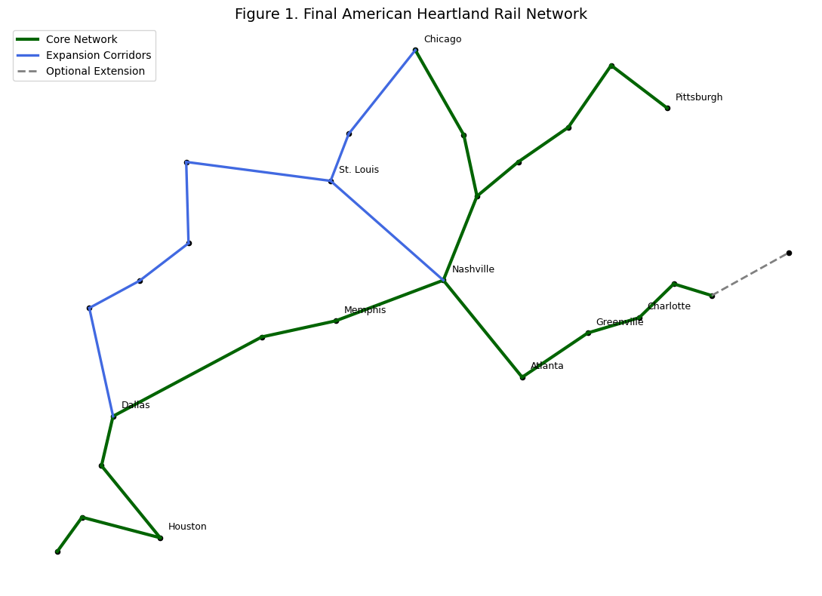

Southwest–Midwest–Ohio Spine:
- San Antonio → Austin → Houston → Waco → Dallas → Little Rock → Memphis
- Memphis → Nashville → Louisville → Cincinnati → Columbus → Cleveland → Pittsburgh

Midwest–Southeast–Carolina Spine:
- Chicago → Indianapolis → Louisville → Nashville → Atlanta
- Atlanta → Greenville → Charlotte → Greensboro → Raleigh

Key Connectors:
- Memphis ↔ Nashville
- St. Louis ↔ Nashville

Plains Corridor:
- Dallas → Oklahoma City → Tulsa → Joplin → Kansas City → St. Louis → Springfield → Chicago

Major Design Insight
System performance is maximized when corridors form continuous chains of mid-sized metropolitan areas, rather than isolated point-to-point connections. This reflects the importance of network effects and trip chaining, where intermediate nodes generate additional demand and improve system-wide efficiency.
The addition of Greenville, SC was found to significantly improve both ridership and system-wide efficiency by densifying the highest-performing southeastern corridor. In addition, the addition of Tulsa, OK, and Joplin, MO, was a major improvement for the Oklahoma City to Kansas City corridor from the originally proposed Oklahoma City to Wichita to Kansas City corridor.

3.2 Rejected Corridors
The following corridors were evaluated and found to degrade system performance:
- Memphis → Atlanta (all variants)
- Nashville → Knoxville → Greensboro
- Dallas → Texarkana → Little Rock
- St. Louis → Evansville / Paducah → Nashville
- Oklahoma City → Wichita → Kansas City
These results demonstrate that geographic intuition alone is insufficient for network design, and that improperly placed links can disrupt system-wide flow and overall efficiency. These results are shown in Figure 2.
Figure 2: Performance impact of evaluated alternative corridors. Several intuitive routes were found to reduce system-wide ridership and economic performance, demonstrating that network structure and corridor chaining are more important than geographic intuition alone.
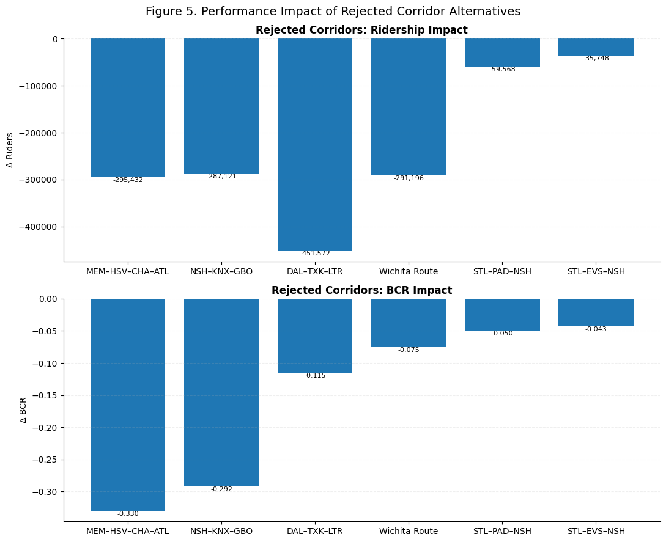

3.3 Optional Extensions
These provide demand but do not improve core efficiency:
- Raleigh → Hampton Roads
- Gulf Coast corridor (long-term)
- Florida system (separate high-demand system)

3.4 Network Design Principle
The system is designed around a core principle: continuous chains of mid-sized metropolitan areas outperform isolated high-demand endpoints.
Rather than maximizing individual corridor demand, the AHR system maximizes network connectivity and trip chaining, allowing multiple medium-demand links to compound into high system-wide ridership and revenue.
The central finding of this study is that network topology dominates corridor-level demand in determining system performance.

4. Results

4.1 Baseline Performance (Final System)
- Ridership: ~9.0M
- Revenue: ~$635M
- Farebox: ~1.37
- BCR: ~2.42
- Subsidy: ~$0.47 per rider
These results establish a strong baseline, but do not fully capture system behavior under uncertainty, which is addressed through Monte Carlo analysis in the following section. The baseline performance is shown in Figure 3.
Figure 3. Baseline performance metrics for the finalized AHR system, showing annual ridership, revenue, public benefits, and operating costs, along with farebox recovery and benefit-cost ratio (BCR). 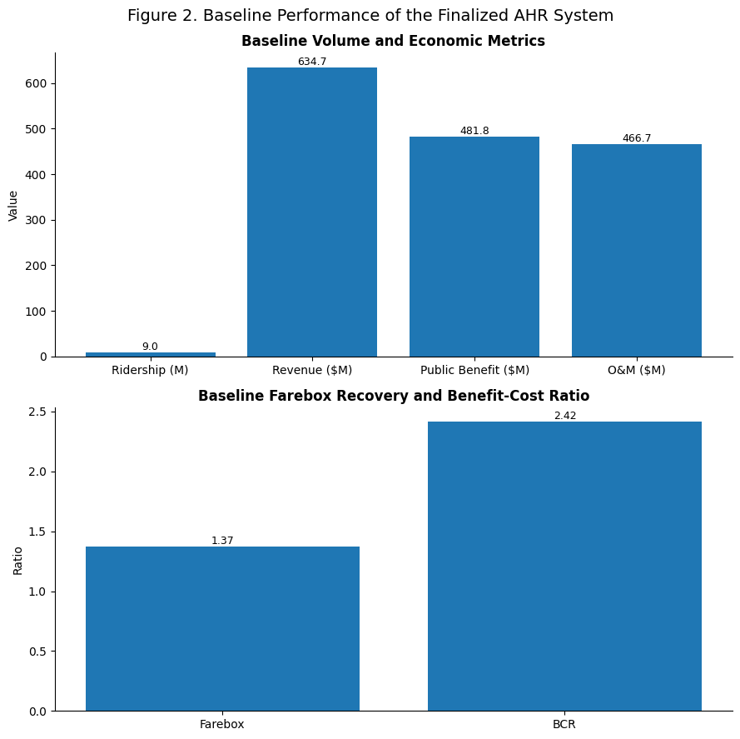

4.2 Monte Carlo Results
- Farebox ≥ 1.0 → 91% of runs
- BCR ≥ 2.0 → 77% of runs
- Zero subsidy → 91% of runs
- Subsidy < $5 → 96.7%
Worst-case:
- BCR: 1.43
- manageable subsidy
Best-case:
- BCR: 3.7
- zero subsidy
These results are shown below in Figure 4. Notably, no simulation produced failure, indicating that performance is driven by underlying network structure rather than favorable parameter selection.
Figure 4. Monte Carlo simulation results for the finalized AHR system. Distributions of benefit-cost ratio (BCR) and farebox recovery demonstrate strong robustness across a wide range of parameter assumptions. Threshold lines indicate key policy benchmarks.
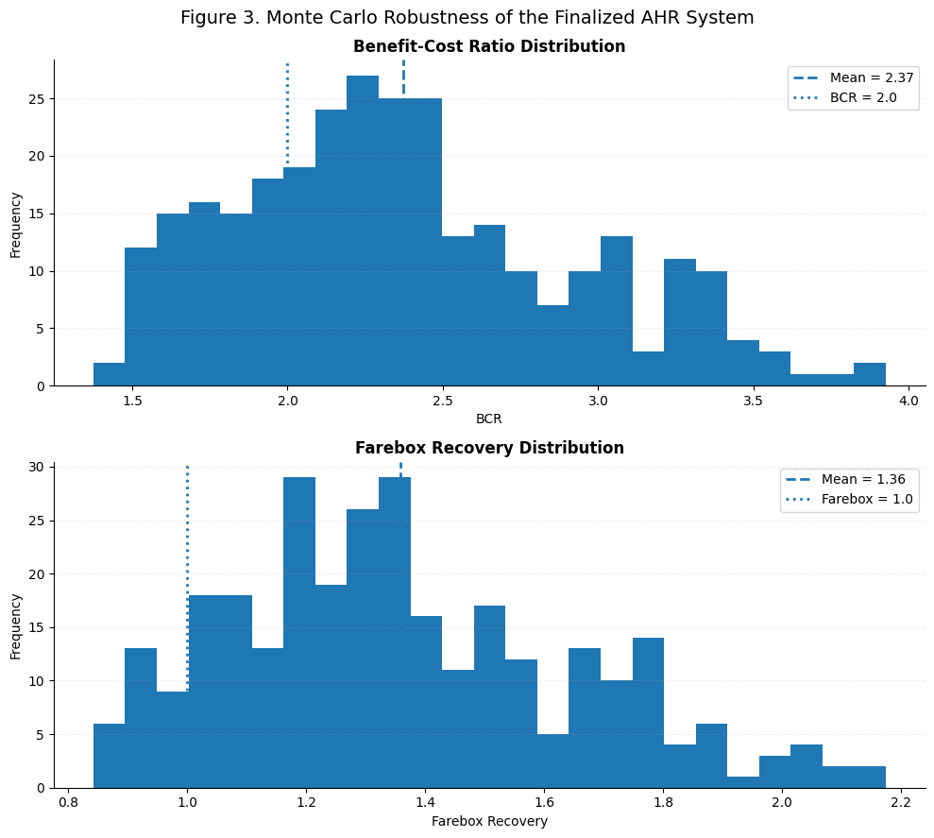

Key Finding
The system demonstrates strong robustness, with no catastrophic failure scenario across tested parameter ranges. These results indicate that the system is not only economically viable in expectation, but highly resilient to uncertainty, with no observed scenarios resulting in systemic failure.

4.3 Network Effects
Expansion into Ohio produces:
- large ridership gains
- strong network amplification
Greenville provides:
- both local demand and system-wide efficiency gains

4.4 Segment Importance
Critical segments, which are shown in Figure 5:
- Austin ↔ Houston
- Cincinnati ↔ Columbus
- Louisville ↔ Cincinnati
- Dallas ↔ Waco
- Atlanta ↔ Charlotte
Figure 5: Segment importance ranking based on ridership loss following removal of individual links. Several key corridors, including Dallas-Waco and Atlanta–Charlotte, are critical to maintaining system-wide performance.
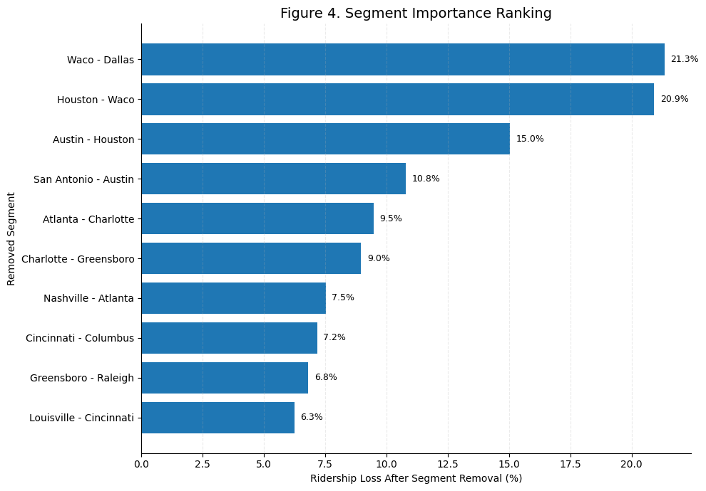

5. Discussion
The AHR system demonstrates that successful intercity rail networks in the U.S. depend on:
- corridor density
- network connectivity
- frequency
The study also identifies three corridor types:
- Core multipliers (improve entire system)
- Terminal extensions (add demand only)
- Regional feeders (connect to hubs)
The system naturally defines geographic boundaries, beyond which additional expansion reduces efficiency.
A key implication of this study is that rail viability in the United States is not strictly a function of population density, but rather of network structure and corridor chaining. This challenges the conventional focus on isolated high-density corridors and suggests a new paradigm for regional rail development.
These findings suggest a shift in U.S. rail planning paradigms, from corridor-centric evaluation toward network-centric optimization. Traditional approaches prioritize high-demand endpoints, while this study demonstrates that intermediate nodes and connectivity structure are equally, if not more, important.

6. Conclusions
- The AHR system is economically viable and robust
- Greenville is a critical addition to the southeastern corridor
- Many intuitive corridors degrade performance
- The system has a clear geographic boundary
- Expansion beyond this boundary should be treated as separate systems
- System viability is driven more by network topology than individual corridor strength
Ultimately, the AHR system demonstrates that economically viable intercity rail in the United States is achievable through strategic network design rather than reliance on megacity density alone.

7. Recommendations
- Prioritize phased implementation of core corridor spines to establish early network effects
- Expand selectively (Ohio, Plains)
- Add Greenville as part of initial design
- Treat extensions as future phases
- Maintain network efficiency over geographic coverage

